

“User Documentation”

- Student name: omar Abuhassan
- student ID Number: 22110264
- Major: Data Science and Artificial Intelligence
- Academic Year: 2nd
- Course Tutor: Dr. Samer Suleiman

1.1 System Overview:

Welcome to alsb' database, designed to simplify your experience in the world of libraries. This database system acts as a simple foundation serving both librarians, staff, and members, facilitating seamless interactions and transactions within the platform.
The purpose of this database system is to store and manage data for a library. The key features of the system include:
- Data storage: The system can store a variety of data, including information about books, authors, members, staff, and transactions.
- Data management: The system can manage data in a variety of ways, including searching, sorting, and filtering.
- Data security: The system provides security features to protect data from unauthorized access.
----------------------------
1.2 Using the system:
Head user:
He can do these things:
- Overview all tables
- Add new data
- Edit all data
- Delete all data

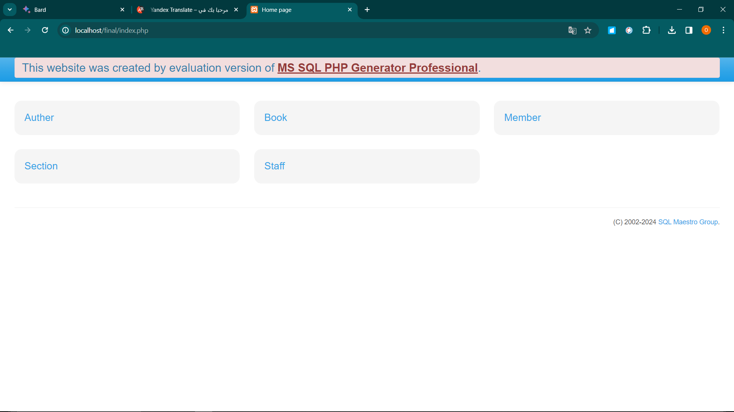
1. Overview all tables
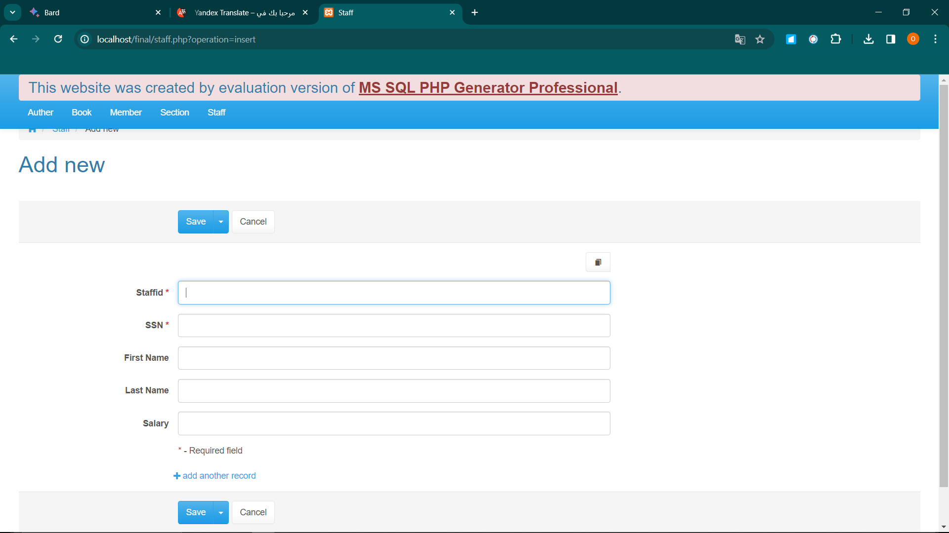
2.

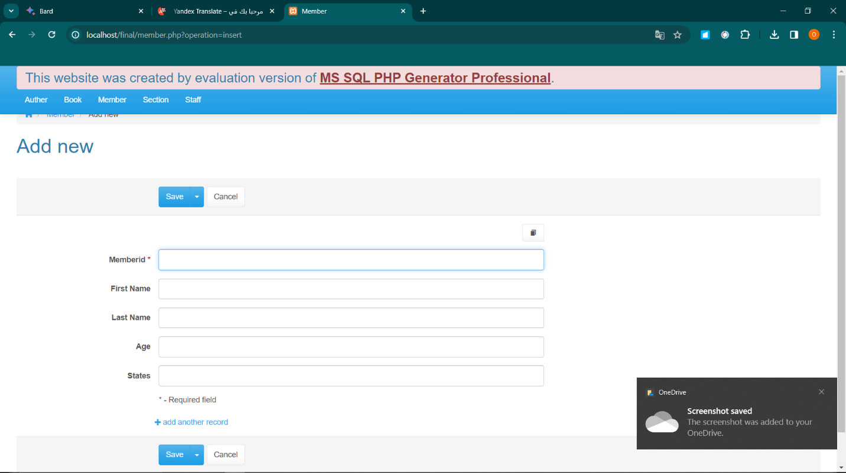

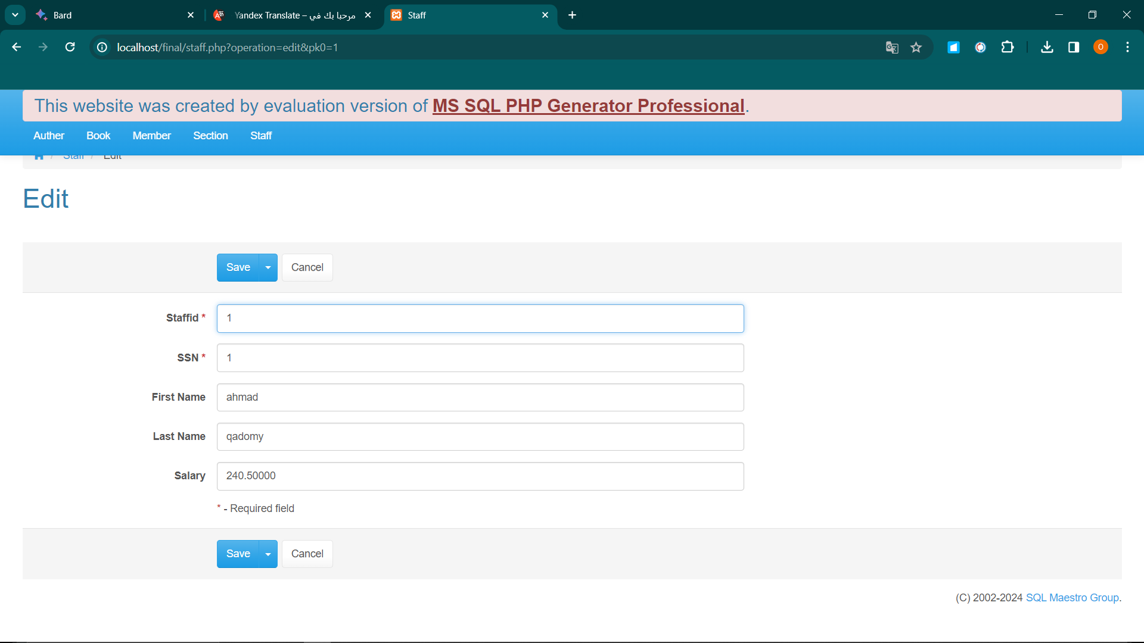
3.edit

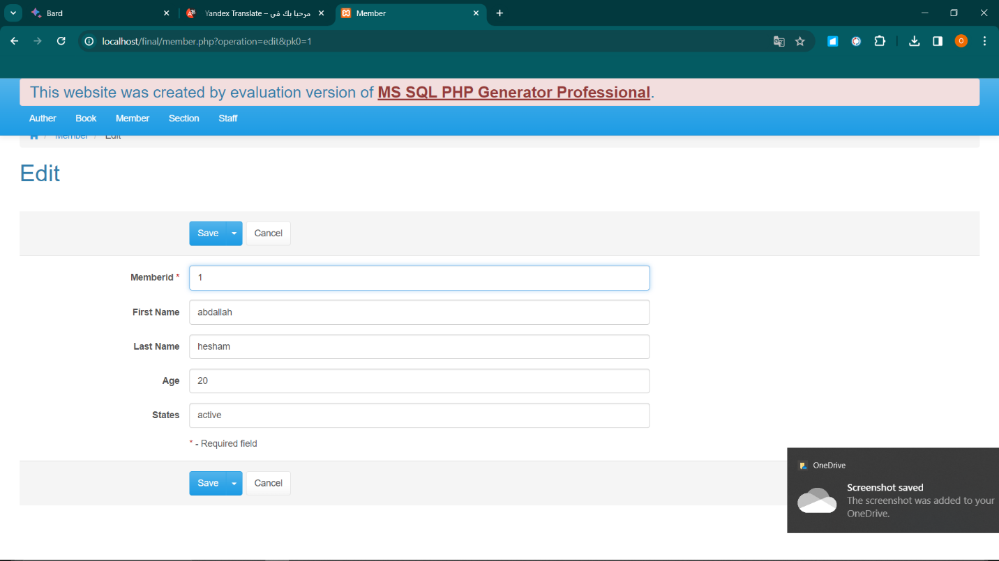

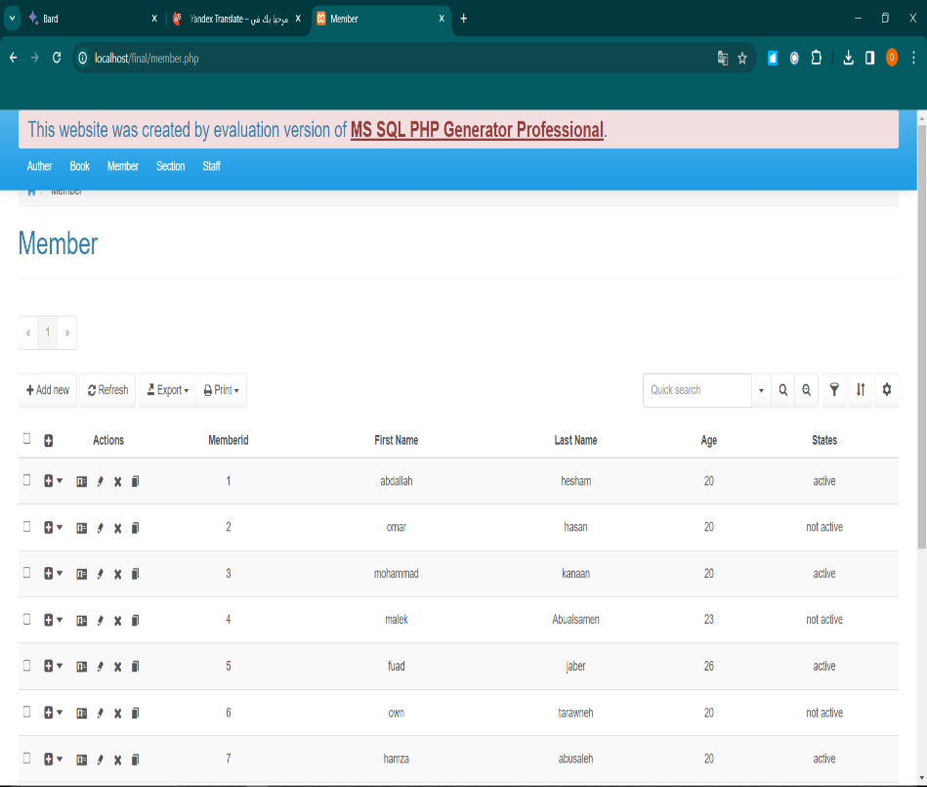
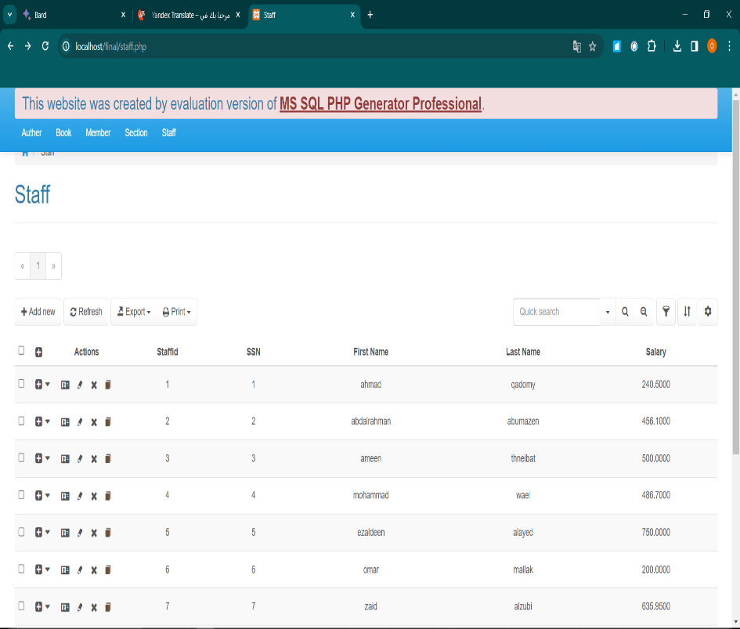
4.delete

1.3 Frequently Asked Questions:
- How can I register as a member?
To register as a member, you should have a valid identity card. You can register personally in the library or online.
- How can I check the book?
To metaphor a book, you must have a valid library card. You can see books personally in the library or online.
- How can I return a book?
You can return books personally in the library or by mail.
- How do I find a book?
You can find books according to the title, author, or category. You can also use the library catalog online.
- I can't find my library card, what can I do?.
If you lose your library card, you can order an alternative card in the library.

1.4 Contact information
Technical Support
- Email : Abuhassan@alsb’.com
- Phone : +962 775300663
- Operating Hours: 24/7

Online Resources
- Visit our http://localhost/final/index.php for discussions and assistance.

